EDUCATION IS THE STUMBLING BLOCK FOR THE MINES OF THE FUTURE

T. Yameogo and J. Suarez

Accenture Canada
145 King St. W., Suite 1401
Toronto, Ontario, M5H 1J8
(Email: t.yameogo@accenture.com)

EDUCATION IS THE STUMBLING BLOCK FOR THE MINES OF THE FUTURE

ABSTRACT

Many ideas, tools, technologies, and methodologies are believed to have staked their claims on the future of mining. For example, automation is strongly positioned as the platform within which mining will be practiced. A subset of automation, intelligent mining, will add some smart interactions between machines, technologies, the rock and the environment. The future also calls for an improved approach to sustainability and corporate social responsibility. Mines of the future are dreamed of to be more ethical, and more balanced. They will boast optimized designs, integrated value and supply chains, produce less waste, recycle and reuse, and will require less energy to operate. Then, what about the people that will operate this optimized ecosystem? How is the education system teaching the operators of the mines of the future? What kind of a future should mining education foresee to prepare the workers appropriately? In recent years, the shortage of skilled labor for mines around the world has created a tough competition to attract, retain and train the very people without whom mining will cease to exist. In Australia, Canada and the United States in particular, the war for talents that resulted in higher-than-usual labor costs. Such costs have dented the unit costs of many mining businesses. Concomitantly, mining contractors’ and consultants’ prices have increased to reflect the escalation of labor costs across the value chain. From labourers to engineers, from juniors to seasoned professionals, the increase in compensation is unprecedented. Yet, the shortage is still hurting the industry, and the high calibre candidates continue to be rare gems. The industry has been implementing aggressive solutions that include the increased hiring of skilled immigrants, the training and recruitment of minorities, and the retaining of near-retirement experienced employees. Public relation campaigns are about the benefits of embracing careers in mining are also common. The CIM has also devoted a “M4S” section to its pan-Canada meetings to educate the public, especially the youth, about the importance of the mining industry for Canada. More, mining associations and universities are enticing students’ enrolment through scholarships and financial support. Still, the balance between quantity and quality of workers can be discussed. This paper intends to discuss the present of mining education as an essential part of the future of mining. The author brushes the picture of the education of miners, technicians, and engineers, against the backdrop of the technology-advanced mines of the future.

KEYWORDS

Mining education, labor shortage, future of mining, miners, technicians, engineers, universities, colleges, technology, automation, mining educators, technology applications, technology preparedness.

INTRODUCTION

The future of mining espouses the development and application of advanced technologies. Automation, intelligent systems, analytics, and sustainability are part of the building blocks of the upcoming mining ecosystem. Those essential pillars have been the center of attention for research projects as well as significant investments. Another crucial pillar is education and the development of talents. It is Nelson Mandela that once said that education is the most powerful tool that can be used to change the world. Benjamin Franklin also believed that “an investment in knowledge pays the best interest”. The shortage of talents in the mining industry is known worldwide, and governments and the mining industry have taken major steps to resolve the issue. While the shortage is still lingering, the potential issue of mismatch between the current education programs and the future technological needs will have to be addressed. In the following paragraphs, the current trends in the workforce and the education programs will be presented. The adequacy of education programs to support the development and application of technological advances in mining will also be discussed.

CURRENT TRENDS IN THE WORKFORCE

The challenges of the labor shortage in mining still plague major producing countries such as Canada, Australia and the United States (Martell, 2012; Robinson, 2012; Blais, 2011). In Canada, the Mining Industry Human Resources Council (MiHR) continues to predict significant requirements to fill the needs of the mining industry. According to a study (MiHR, 2011), the Canadian mining industry needs thousands of additional people in the next nine years to cope with career changes and retirements. Based on a business-as-usual scenario (‘baseline’), at least 112,000 new hires will be needed between 2012 and 2021.That represents more than half of the current workforce. As shown in Table 1, the industry would require even more workers (141,540) if the industry expands. Even in an economic contraction, there is still a demand for 75,280 employees that needs to be satisfied.

Table 1 – Scenario-based Cumulative Hiring Requirements for the Canadian Mining Industry (2011)

Mining Economics | Job Change | Retirement | Non-Retirement | Cumulative
Contractionary | -28,200 | 61,550 | 41,930 | 75,280
Baseline | -1,000 | 67,080 | 45,940 | 112,020
Expansionary | 20,500 | 71,740 | 49,300 | 141,540

Although the overall industry is faced with the shortage, the demand for some occupations is more critical than that of others. Figure 1 details the requirements by occupations, for the baseline scenario. Trades and undesignated occupations (55% of the total) are a major concern, followed by support workers (17%) and first line managers (13%). The MiHR (2011, p. 14) identified the following occupations as being specifically critical, as they represent more than a third of the total requirements:
- Production clerks
- Heavy-equipment operators (except crane)
- Truck drivers
- Underground production and development miners
- Construction millwrights and industrial mechanics (except textile)
- Primary production managers
- Welders and related machine operators
- Heavy-duty equipment mechanics
- Machine operators, mineral and metal processing
- Labourers in mineral and metal processing

The requirements across provinces also vary due to the regionalization of commodities, services and history. Between 2011 and 2021, the majority of the needs will be in the Prairies, where an economic boom has been ongoing.

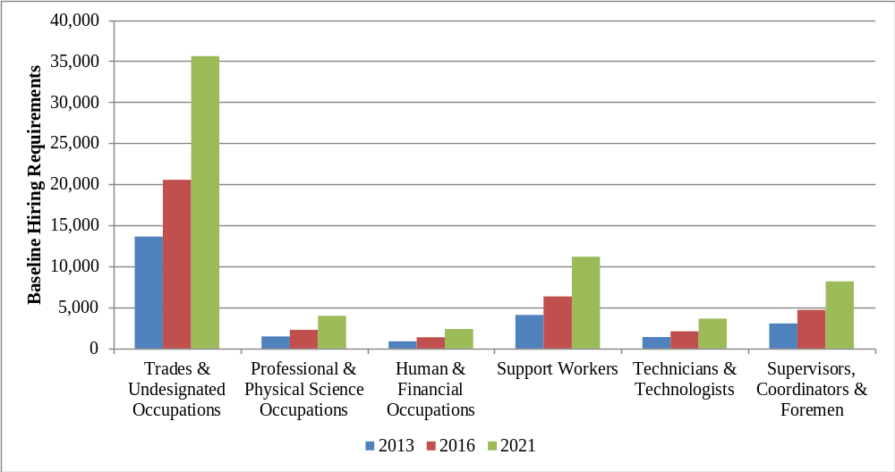

Figure 1 – Hiring Requirements by occupations in the baseline scenario (MiHR, 2011)

In addition to the numbers (quantity), there is also a challenge attracting the experience and expertise (quality). Recently, HD Mining, a BC-based coal mining company, was allowed to hire foreign temporary workers to outfit its Murray River Project. The lack of experienced Canadians to safely operate longwall coal mining was cited as the main reason. Although the issue spurred a huge controversy with governments and unions, it indicated that the search for qualified workers has become a major concern in Canada. According to a study by the Center for the Study of Living Standards (CSLS), the quality of the workforce has a direct impact on the labor productivity, which, in the case of the Canadian mining industry, has been deteriorating partly due to the rapid employment growth on pools of lower quality workers (CSLS, 2009, p. 36). While the economic growth is in itself positive, lower education attainment and workforce composition are to be blamed for the decline in productivity.
Industry reports (MiHR, 2010, p. 15; CSLS, 2009, p. 37) have focused on the lower education levels in the Canadian mining workforce. Using data from the 2006 census, they demonstrated that the mining workforce is less educated, when compared to the average Canadian labor force (Figure 2):
- only 11% has a university education, versus 22% for the other industries
- 18% has no certificate, diploma or degree versus 15% for the average labor force
- 3% has technician/technologist education, versus 5% for the average labor force
However, “in the mining occupations where a university education is likely required (e.g., engineering, geosciences and management positions), a higher proportion of the workforce has university degrees than in other industries” (MiHR, 2010, p. 15). Still according to Figure 2, the main source of labor is noticeably from trades and apprenticeship (21% in mining, versus 12% on average); thus, a correlation between the requirements in Figure 1 and the statistics in Figure 2.

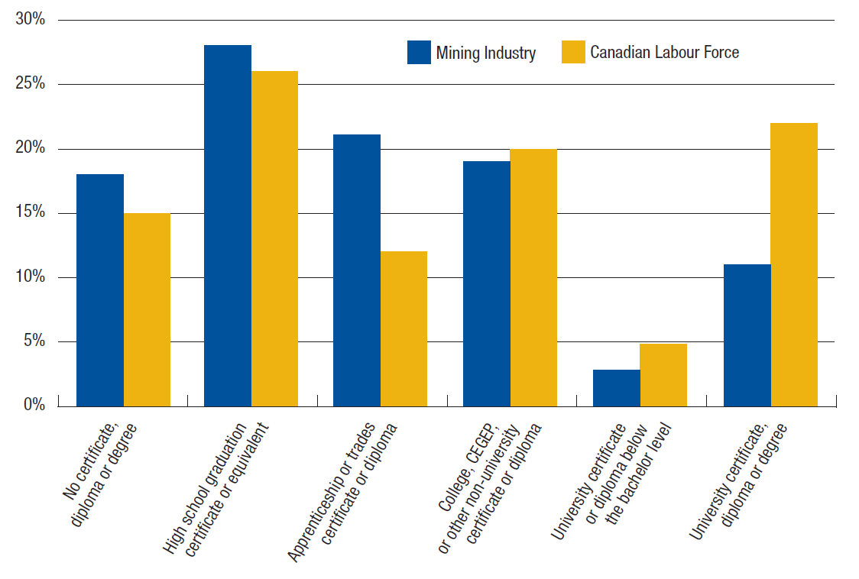

Figure 2 – Mining employees’ education levels compared with Canadian labor force (MiHR, 2010)

Another method of assessing the quality of the workforce is through the analysis of labor composition, a ratio of labor input to the hours worked (CSLS, 2009). An increase means an improvement in education attainment and work experience. Figure 3 shows the trend in labor composition in the mining industry, in comparison to data of the business sector. Mining has experienced an improvement in quality workers in the period of 1989 to 2000. However, a significant drop occurred afterwards, and has been attributed to the “deterioration in the quality of mining industry’s workforce relative to other industries” (CSLS, 2009, p. 38).

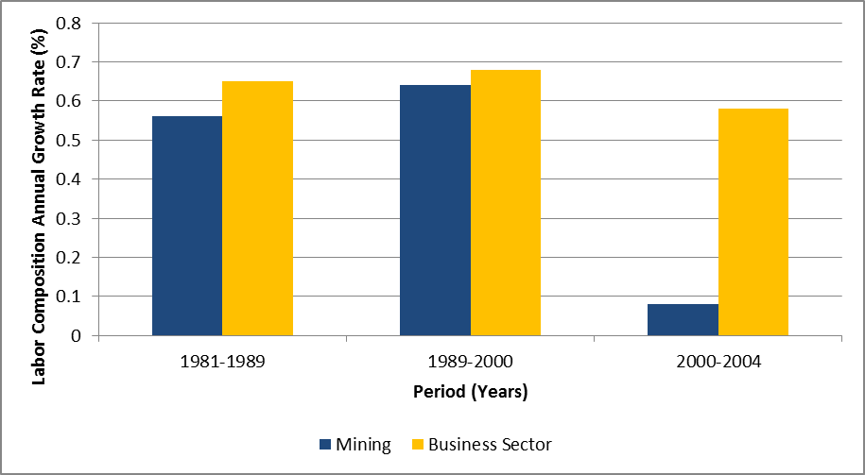

Figure 3 – Trends in labor composition (CSLS, 2009)

Figures 1, 2 and 3 indicate that the labor shortage faced by the mining industry is more than a numbers game. Filling the hiring requirements by massively recruiting and retaining workers is not enough to address the issue. The crisis is not only occupation-based, but also quality-focused and provincially-differentiated. The next section discusses the education system that train new workers to join the mining industry.

EDUCATION PROGRAMS AND TECHNOLOGICAL ADVANCES

In nearly all universities in Canada, mining-related education can be acquired. Many community colleges offer mining education programs as well. The strength of the accredited programs varies, and programs have different foci depending on the commodities and mining methods in the immediate regions. Colleges and universities in Alberta for example would have strong education emphasis on oil sands, and students in British Columbia will learn more about open pit mines. But, the question is whether the programs equip students with the knowledge required to function in the technological-advanced mines of the future. Though technology attracts young people, mining programs hardly boast about technology and innovation in their curricula. Most advertising campaigns continue to focus on high salaries, outdoor living, travels and scholarships as enrolment incentives. This is partly due to the crisis of low enrolment that plagued almost all mining programs in Canada. In fact, students’ enrollment and graduation have been increasing since 2008, and that seems to have secured mining programs within universities (Scoble, 2009; Hadjigeorgiou, 2008). Educating those students and placing them in the industry may actually become a challenge in an economic downturn, especially if the programs do not suit industry needs, or if the quality of the graduates is not acceptable.

The debate on mining education content of mining programs has been researched by academics at Queen’s University (Heuchan & Archibald, 2011). The authors interviewed mining operators to assess the quality and appropriateness of new hires from the mining engineering programs. The study asserts that university education, though in tune with industry needs, is less than ideal in many areas, especially for specialized computer applications. Besides the limits that interviews bring, the study is an important quest into the technology preparedness of the mining education programs. Lack of resources and industry support, and minimal university support are usually blamed for the suboptimal conditions. Consolidation amongst university programs has been discussed as a solution to increase the strength of the programs and coalesce funding. The joint ‘McGill University and Ecole Polytechnique’ program in Montreal is an example, but some academics oppose the idea for various reasons (Meech, 2007).
Changes in the curricula are also discussed. In place of the current curricula, the modern mining curriculum should include the main features of the mines of the future, which are automation and robotics, sustainability, and technology applications (Meech, 2007). Most mining programs have enhanced their curriculum to add sustainability and the environment, both of which are trendy in the world today. Automation, robotics, and technology applications are still embryonic in many mining programs, not only because they require more investments, but also because the collaboration between manufacturers, universities and the industries is minimal on these topics.

The situation in trades’ colleges is similar, although enrollment numbers tend to be higher due to the less stringent entry requirements, the lower tuition fees, the shorter lengths of the programs, and the hands-on aspects of the education. But the quality of graduates has recently been a concern for the industry. One reason could be the overall sense of a diluted education, while a possible explanation may be the obsolescence of the education programs with regards to technological advances. Colleges may be teaching the same curricula, or teachers may not have the mining experience that goes with high quality education. One third and plausible reason comes from the externality of a generational and socio-economic change. According to Robinson (2012), the old, yet still in use, apprenticeship model in Canada is no longer functional because the socio-economic reality has changed. In the past, an apprentice would be pay minimal wages in exchange of learning the tricks of the trade for some years. By the time graduation comes, an apprentice would most likely remain with the employer for more years. Today, young people require higher wages and change employers more frequently. Since employers cannot be certain to recover their “education investment” from apprentices, they rely on governments to provide such training. The content of the curriculum is then designed outside of the industry, and may be insufficient for the mining industry needs. That is potentially problematic when trades and apprenticeships represent the largest source of talents the industry will rely on for the upcoming years.

Another looming but hidden crisis is that of the educators. Mining teachers and researchers are a wealth of knowledge that universities and colleges are slowing being eroded of, due to retirement and career changes due to unattractive compensation and working conditions. Even though donations for research institutes are now common and sponsored by the mining industry, it takes time and effort to craft a knowledgeable teacher. In addition, there is a silent but tough recruitment and retention competition between the mining companies, the mining services, the government agencies, and the teaching institutions.

CONCLUSION

The labor shortage in the mining industry is being addressed mostly through aggressive enrolment campaigns in university and college programs, the inclusion of minorities, women and immigrants in the workforce, and the rescheduling of retirements. While these solutions are required to fill the vacancies, a major challenge is to ensure that an appropriate quality of new graduates enter an industry that is being transformed by technology and innovation.

The future of mining is that of advanced technologies from the exploration stages to the decommissioning and reclamation phases. Robotics, automation, and technology applications will require highly qualified workers, a fundamental enhancement to the current profile of the workforce. The investments in education have to address the gaps in the curricula of colleges and universities to match the industry needs to the knowledge that is being taught to students. To do so, it’s essential that the mining industry, especially the mining operators, participates even more in the accreditation of mining-related programs across the country. For example, the modern mining engineering curriculum (Meech, 2007), could be a dynamic reference for Canadian mining engineering programs. Customized hiring and retention processes for mining professors could also to be reflected on. Considering the independence of teaching institutions, consolidation may be challenging to establish. However, industry sponsorship and donation can be optimized to ensure that centers of excellence thrive and support the industry needs even more. An organization within the Canadian Institute of Mining, Metallurgy and Petroleum (CIM) could help orient and manage such strategy. In fact, the Canadian Mining Innovation Council (CMIC) may be the appropriate candidate for such involvement in the curricula and the industry investment in the education institutions.
Company in-house training and other online training and simulation could offer workers the opportunities to upgrade their skills post college or university. In doing so, the overall education level of the mining industry can be improved without losing employees, who may be enticed to stay following the free education upgrade. While companies may be reluctant to pursue this option due to additional costs and employees’ mobility to competitors, the below-par education may force them to. In fact, virtual mines are being set up by some major mining companies in collaboration with education institutions.

The additional 112,000 people required to operate the mines by 2021 may still be missing if the college and university intakes remain low, or if more attractive conditions are offered elsewhere such as Australia and the United States, or if other sectors of the economy become more attractive (e.g. energy sector depletes mining from its already scarce workforce). One proactive and seemingly more sustainable approach is automation and robotics. Not only do they reduce the size of the workforce required to perform the same activities, but they also replicate the qualities of the best teams into reliable, efficient and effective routines. For example, autonomous haulage trucks will decrease the incremental need of truck drivers, an occupation in serious crisis. More technology applications may also reduce the levels of experience and expertise that is currently needed to perform certain occupations by allowing the worker to focus on less taxing activities. For example, the use of integrated positioning systems allows surveyors to take on more meaningful activities. Therefore, technology and innovation can help solve the shortage of high quality labor, and lead to an increase in labor productivity.

REFERENCES

Blais, N. (2011, Aug). Facing the Mining Labor Shortage to Fill Global Mining Jobs. Retrieved Jan 2013, from info.cowaninternational.com: http://info.cowaninternational.com/international-mining-recruitment/bid/62369/Facing-the-Mining-Labor-Shortage-to-Fill-Global-Mining-Jobs
CSLS. (2009). A Detailed Analysis of the Productivity Performance of Mining in Canada. Ottawa: Center for the Study of Living Standards.
Hadjigeorgiou, J. (2008). A Snapshot of Mining Engineering University Education in Canada. CMIC .
Heuchan, J., & Archibald, J. (2011). Industry and Higher Education - Meeting the Needs of the Mining Engineering Sector. Kingston: Queen's University.
MAC. (2012). Facts and Figures of the Canadian Mining Industry . Ottawa: The Mining Association of Canada.
Martell, A. (2012, Sep 06). Mining Companies Combat Labour Shortage with Training, Bonuses. The Globe and Mail.
Meech, J. (2007). Producing the Mining Professionals Required for the 21st Century. Vancouver: University of British Columbia.
MiHR. (2010). Canadian Mining Industry Employment and Hiring Forecasts. Kanata: Canadian Mining Industry Human Resources Council.
MiHR. (2011). Canadian Mining Industry Employment & Hiring Forecasts 2011. Kanata: Mining Industry Human Resources Council.
MiHR. (2011). Unearthing Possibilities: Human Resources Challenges and Opportunities in the Canadian Mineral Exploration Sector. Kanata: Canadian Mining Industry Human Resources Council.
MITAC. (2005). Prospecting the Future: Meeting Human Resources Challenges in the Canadian Minerals and Metals Industry. Ottawa: Mining Industry Training and Adjustment Council.
Robinson, D. (2012, March). No Good Deed Unpunished - Mining Supply and Services Labour Shortages. Sudbuty Mining Solutions Journal.
Scoble, M. (2009). Canadian Mining Education Review. Vancouver: University of British Columbia.
Smedley, K. (2012, Jun). Global Mining Jobs : Mining Engineers and Geologists in Short Supply. Retrieved Jan 2013, from info.cowaninternational.com: http://info.cowaninternational.com/international-mining-recruitment/bid/84209/Global-Mining-Jobs-Mining-Engineers-and-Geologists-in-Short-Supply

