LEADER EMPOWERMENT: A JUNGIAN APPROACH

Abstract:
Based on the metaphor of the leader as a tool for effectiveness, traditional leadership literature assumes leadership either to be the result of innate personal traits or to develop out of a conscious intellectual praxis. In this perspective leadership success comes from the conscious understanding of leadership concepts. Replacing the traditional “tool” metaphor by the image of a leader as an “inner self explorer”, this research assumes leadership failures to essentially result from psychological blockings. Starting from the major causes of leadership failures pointed out in literature this research develops a theoretical framework connecting the psychological origins of these causes with specific psychological blockings using Jungian theory and the individuation process. To achieve leader empowerment, leaders interact with and integrate archetypes of the second and third phase of individuation. This work offers a new perspective on leader behavior and sheds light on the psychological requirements for leader development.

Key words: leader development; leadership failures; analytical psychology; individuation; leaders empowerment

1. Introduction
Leadership literature is rich, diverse and increasingly available. Social networks spill over with insights into what leaders are, how they should behave and develop their skills. The reason for such interest in leader development might come from the perception by executives that management tools are accessible to everybody. The Praxis of leadership appears to be a way of differentiation and a lever for managers’ careers. Leadership is the ultimate tool to achieve professional and personal success.
Despite abundant leadership literature and the notable generalization of leadership training leadership failures remain frequent and seem to have ever increased. Some authors attribute these failures to the content of leadership literature: “Most of the theories are beset with conceptual weaknesses and lack strong empirical support. Several thousand empirical studies have been conducted but most of the results are contradictory and inconclusive” (Yukl 1989, p.17). Beyond such skepticism, interested readers can find a range of suggestions on how to avoid leadership mistakes in the main strands of literature. Trait theories focus on particular personal characteristics, contingency theories emphasize the importance of situational awareness, and followers of the transformational approach praise the virtues of leading with inspiration and passion. Leadership learning programs include the analysis of mistakes of leaders and suggest the potential resolution of leadership problems through the rational and conscious means available in leadership literature. But leadership failures do not come solely from mistakes. The work of Goleman (2002), Boyatzis (2008) and Fry (2008), puts more emphasis on the psychological abilities required for successful leadership. In leadership failures, Psychological blockings appear to be more important than actual mistakes. “In psychology, the term blocking refers broadly to failures to express knowledge or skill because of failures of learning“ (Moore and Schmajuk, 2008). Such blockings are not contextual as for mistakes, but structural psychological limitations, which might prevent leadership learning processes (Figure1). In the case of blockings, potential leadership improvements do not come mainly from rational and conscious effort but primarily from some form of self-actualization.
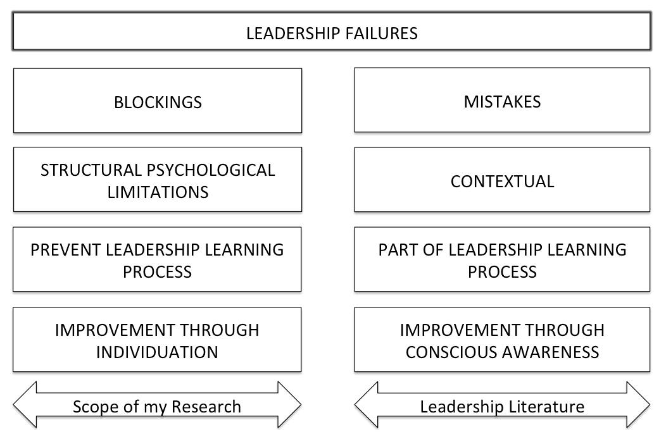
Figure 1: Reasons for leadership failures

Traditional literature assumes leadership either to be the result of innate personal traits or to develop out of a conscious intellectual praxis. In both cases, leadership is apprehended as a tool for effectiveness. Metaphorically, leadership training based on traditional literature provides the manual for a piece of equipment without knowing whether the person has the (psychological) capacities to handle the tool or not. The development of new techniques for effective leadership cannot resolve that essential problem. This research extends existing knowledge by replacing predominant instrumental assumptions concerning successful leadership with a new assumption that represents leadership as the result empowerment. Empowerment in this case is a holistic psychological development process encompassing all dimensions of the human psyche. This new assumption allows novel insights. Leadership arises from psychological capability before it becomes a managerial reality. The objective of this research is to determine the psychological preconditions required for the empowerment of leaders. This article endeavors to find the psychological prerequisite to leader empowerment and therefore belongs to the field of leader development.
The following section provides a short overview of leadership approaches, their basic assumptions and resulting gaps. Based on elements of Jungian psychology section three develops a theoretical framework explaining the causes of leadership failures and how these causes can be eliminated. The paper concludes with a discussion of the contribution of the suggested new assumption and resulting theoretical framework to existing leadership knowledge .

2. Literature Review

2.1 From main leadership theories to recent leader development literature
Main leadership theories
Personal gift or social knowledge? Leadership theory has always been is a product of its time. Since Hippocrates constructed personality types derived from ‘body humor ‘, many approaches to leadership have considered character as the main criterion for leadership evaluation.
Trait theories emerging out of Great Man theory played an important role in identifying the particular qualities of great leaders. As these theories gave no account of contextual issues, behavioral approaches gradually replaced them by moving further away from the idea that leadership is innate and dependent upon fixed personal qualities. The idea that there is no single one “right way” as well as the fact that leadership is often very relative to situations led to the development of situational and contingency theories. In situational theories the leaders adapt to situations (Fiedler & Garcia 1987, Vroom & Yetton 1973). In contingency theories, the circumstances have to be adapted to the leader’s style (House 1971, House & Mitchell 1974). In both cases, leaders must closely examine the context.
Highlightening the importance of generating interest among employees and of helping them see beyond their individual interests, Bass (1985) opened the way to transformational leadership theory.
Commenting on transformational leadership, Bass and Steidlmeier (1999) point to the existence of pseudo transformational versus authentic leaders. Authentic leadership is “a process that draws from both positive psychological capacities and a highly developed organizational context, which results on both greater self-awareness and self-regulated positive behaviors on the part of the leaders and associates, fostering positive self-development” (Luthans & Avolio 2003, 243). Avolio and Gardner (2005) develop this difference further and provide a theoretical framework in which authentic leadership “focuses on the formation of authentic relationships between the leader and followers that are characterized by trust and integrity” (Gardner, Avolio, & Walumbwa 2005, pp. 389).
Some research shows how people having positive psychological mindsets are more likely to develop the skills and resources required to perform (Frederickson 2001).
Leadership research based on cognitive science covers a wide range of approaches analyzing information, thinking and processing in leadership contexts. This stream of research includes many concepts related to leader development from the perspective of leaders and followers, such as self-concept theory (Altrocci 1999), meta-cognitions, or implicit leadership theory (e.g., Lord & Emrich 2000). Lord and Hall (2005) also show the importance of a leader’s cognitive abilities. Mumford (2003) develops a model demonstrating how the effect of shared thinking favors leader creativity.
Kets de Vries follows the tradition of the Tavistock Institute of Human Relations which, since the 1940’s, has been investigating systematically institutions while showing the importance of psychoanalytic factors. His approach is an attempt to link psychodynamics with the theory of organization (Kets de Vries, 1995; p13).
The literature on Resonant Leadership (Boyatzis, McKee & Goleman 2002) explores the field of emotions. Resonant leaders use emotional and social intelligence skills to develop themselves as well as to contribute to the balance and fulfillment of others. The resonant leader is a coach. Leadership is about quality relationships based on the three pillars of mindfulness, hope, and compassion. Mindfulness is the full awareness of our environment and our own awareness within it. Hope is about having clear goals, believing in the possibility and the necessity of their achievement as well as their contribution to a sense of well-being. Compassion is about acting in the interest of others (Boyatzis, 2002). Resonant leaders manage their emotions and handle emotions of others. They facilitate empowerment of collaborators and build confidence within their teams.
Fry (2003) presents spiritual leadership as a a holistic vision of human existence through body, mind, heart and spirit (Fry 2003) “comprising the values, attitudes, and behaviors that are necessary to intrinsically motivate one’s self and others so that they have a sense of spiritual survival through calling and membership” (Fry 2003, p.771). Calling refers to meaning and making a difference. Membership refers to the feeling of being understood and appreciated (Fry 2003). Spiritual leadership promotes spirituality in order to enhance calling and membership. Spiritual leaders metaphorically take the role of Pontiff, the one building bridges. Spiritual leadership seeks for meaning and inner discovery. This stream of research investigates how using symbolic attributes and providing spiritual meaning can improve leadership.

Leader development
Leadership theory can actually be divided in two main streams: leader development and leadership development. Leadership development is about the interpersonal dynamics of leadership. Leader development is about focusing on an individual’s capacity to contribute to leading processes. This research is about leader development.
According to McCauley, there are three main streams within leader development : « research that focus on the individual leader and his or her developmental path, studies that examine the impact of various leader development methods, and studies of organizational practices for leader development » (McCauley, 2008).
This research falls under the first of these 3 streams : the examination of how the capabilities required for leadership roles can be developped.
Various studies aim at identifying major causes for the development of leaders.
Challenging assignments, influence of other people, hardships, courseworks and personal life experiences appear as the main events that triggered leadership abilities (McCauley, 2008). Many interviewed leaders mentionned having learned lessons and from these lessons having developped precious leadership qualities such as flexibility, perseverance or optimism (McCall & Hollenbeck, 2002). Bennis and Thomas (2002) call these transformational experiences, crucible experiences. According to the researchers, these experiences are diverse in nature but all imply basic leadership competencies : adaptive capacity, engagement of others by creating shared meaning, voice (self confidence) and integrity.

All of these studies have had an important impact on leader development and encouraged leaders to look beyond formal management training to develop their leadership skills (McCauley, 2008). However, leader development studies rely on past experiences and on the memories leaders have of their transformational experiences. Whether these experiences can apply to other people or other contexts remains open to further research. Moreover, no clarifications are made as to what are the specific psychological mechanisms or forces that trigger these personal changes.

2.2 Problematization of existing literature and underlying assumptions
At this stage, the leader development literature, as well as the main body of leadership literature in general, is primarily interested in the leader’s rational and conscious relation to leadership.
Despite apparent heterogeneity, all approaches build on one of two basic assumptions: either leadership is innate (trait theories) or it develops through the intellectual understanding of its mechanisms. A common metaphor characterizing all of these approaches is the leader as a tool. Some of these assumptions neglect emotional as well as spiritual factors to focus rather on intellectual and material conditions. More recent streams of thought approach leadership from a less instrumental perspective giving more importance to emotional and spiritual factors. However, being based on the tacit assumption that the needed individual psychological conditions for leadership are in place- the approaches primarily focus on how to improve leadership effectiveness rather than on how to determine the psychological conditions needed for leadership.
By focusing on leadership mistakes, mainstream literature assumes that leaders can be rational, conscious of their own weaknesses and able to improve their leadership through reason and goodwill (Figure 1).
The intellectual tools provided in this literature can be effective if the leaders have overcome their basic psychological limitations. The limitations of such leaders are not of intellectual but of personal nature. They come from psychological blockings, which need to be addressed by going beyond reason, considering the individual from a holistic psychological perspective that is a psychological approach encompassing all four functions of the psyche: Intellect, Emotion, Sensation and Intuition.

This research suggests dropping the view of leaders as tools for efficiency and effectiveness (Judge & Piccolo 2004). Focusing on leader development allows replacing the tool metaphor for leaders by the metaphor of “The Inner Self Explorer”. Leadership can only be considered as a tool once the leader has developed adequate capacities. Such abilities need to be developped beyond the realm of the teknê. In order to achieve such abilities, the leader has to engage into a genuine introspection and self development process. Jungian theory provides an interesting ground for such an endeavor. C.G Jung considers human development as on going process which is not solely anchored in material and rational dimension (respectively corresponding to the sensory and intellectual psychic functions). By establishing the existence of two other psychic functions (emotional and spiritual), Jung encourages individuals not only to acknoweldge these dimensions but also to develop and explore them. Leader development can not only be based on material and rational grounds and needs to encompass emotional and spiritual realms (figure 2).
Successful leadership becomes possible once the leaders have resolved their deeply rooted psychological blockings. This research assumes that people who empower themselves by the full acceptance of their individual specificities are freed from the blockings that restrict their leadership potential. The objective is to develop theoretical propositions based on Jungian psychological theory relating leadership failures with psychological blockings and the three steps in individuation suitable for dissolving these blockings.
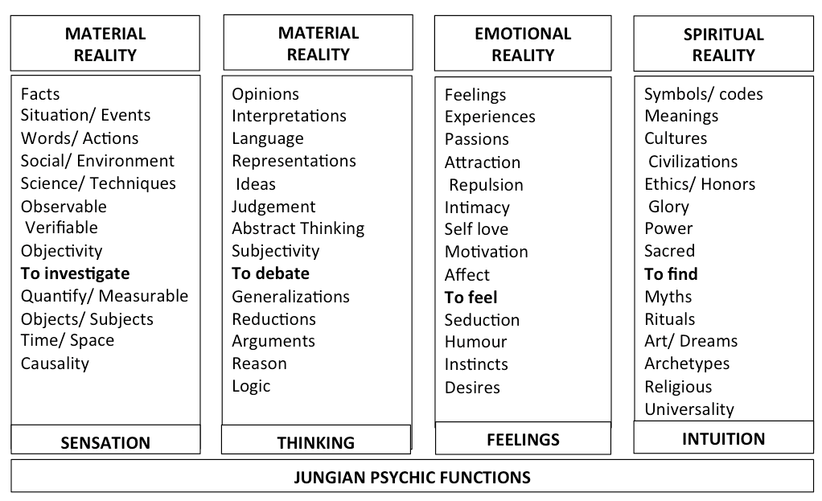
Figure 2: Jungian Psychic Functions

3. Theoretical framework

3.1 Causes of leadership failures resulting from psychological blockings

Literature is very scarce when it comes to leadership failures. Burke, Clements and Washbush (1999) believe that one can learn as much from leadership failures as from leadership successes. Complete understanding of leadership is not possible without an exploration of its dark side. Following Burke this ignorance is « confusing misleading and limiting to the development of good leaders » (Hogan, Raskin and Fazzini, 1990, p-343). Kelllerman (2004) identifies seven types of bad leadership. The bad leader will commonly be: incompetent, rigid, intemperate, callous, corrupt, insular and evil. The first three are ineffective the last four are unethical. Summarizing the writings about leadership failures Burke and Cooper (2006) notice some failures being related to interpersonal and social skills (arrogant, stubborn, egocentric). Other failures come from the fear of making mistakes (cautious, avoid responsibility). A third type of failures stems from emotional and relationship problems (impatient, moody, negative, volatile, emotional instability). Lastly, skepticism and distrust, cause many failures reducing leaders effectiveness in motivating others. These leaders are cynical and appear untrustworthy.
Distinguishing major themes of the literature of leadership derailment, Burke (2006) identifies six major causes for leadership failures: arrogance, perfectionism, aloofness, insensitivity, selfishness and betraying the trust of others (Figure 3). Psychological blockings are the potential reasons of each of these leadership failures. Arrogance relates to observable cases of leadership behavior characterized by an abnormal love of self, an exaggerated sense of superiority and a strong preoccupation with success and power. Such behavior can be understood as a compensation for deeply sensed insecurity and a very fragile self-esteem (Winch, 2014).
Perfectionism originates from a fear of failure due to specific educational standards during childhood (American Academy of Pediatrics 2003). Anything short of perfection is unacceptable. ”Gifted children who experience frequent success are especially vulnerable to perfectionism“ (Rimm 2006).
Insensitivity, the fear of being emotionally hurt, and aloofness, the fear of being rejected manifest in coldness. Cold leaders do not only fail in motivating followers, they also involuntarily create suffering among followers. According to Seltzer (2011) avoidant attachment is the primary cause for aloofness and insensitivity. Aloof people are just trying to protect themselves against vulnerability.
Selfish leaders are concerned excessively with themselves, concentrating on or seeking their own advantage, pleasure or well-being without regard for others. In management context, selfishness comes with greed. Anderson (2014) proposes three antecedents of perceived greed: distributive injustice, inference of a selfish motive to acquire and relative deprivation. Greed and selfishness come from the inability to detach oneself from a representation of self, which corresponds to a wonderful child who should never be deprived (Anderson 2014).
Betrayal of the trust of others comes from an irrational drive for safety and protection beyond any ethical consideration (McDowell 2014).
The common thread among these possible causes of leadership failure is self-centeredness. Self-centeredness is deeply rooted and cannot be dealt with in an exclusively rational manner. Leaders need to reach holistic self-awareness, encompassing conscious and unconscious resources, to become able to broaden their self and to enrich and improve their relationships with others.
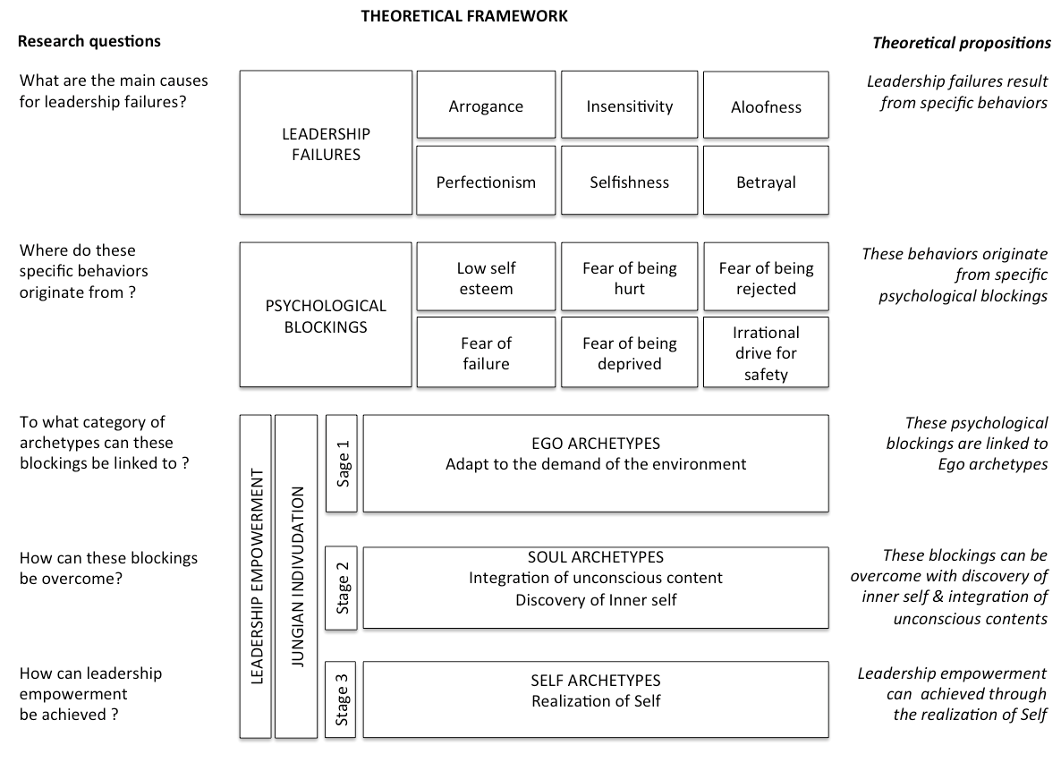
Figure 3: Leadership failures, psychological blockings and individuation

3.2 Removing psychological blockings through individuation

The work of Jung is particularly relevant for finding a way to overcome psychological blockings. Jung has developed an approach, which aims to understand and amplify the dimension of reality, which comes to us from beneath the consciousness threshold (Progoff, 1969).
Freud provided the basic grounds for the acknowledgement of the unconscious. However, Freud’s approach is primarily materialistic and biological. Freud neglected history and religion (Progoff, 1969). Rationalistic thinkers failed at penetrating the roots of human motivations. To understand drivers of human behavior factors such as "desire" or "self-interest" appeared quite satisfactory. Jung's conception and interpretation of the psyche does not consist of considering solely biological factors. It encompasses historical approaches as it emerged of a social rather than a purely biological conception of human. Jung provides a framework that is better suited for a subject such as leadership, which is grounded in psychology, sociology, anthropology, political philosophy and is not totally unrelated to mythology and religion.
Jung’s analytical psychology attributes importance to the individual psyche, the personal quest for wholeness and the importance of the symbolic in human life. According to Jacobi (1968), Jung’s deep understanding of psychic reality is not at all based on abstract grounds. Jung is above all an empiricist.
According to Jungian theory, the psyche consists of two complementary and opposite spheres: the conscious and the unconscious. The conscious is the activity linking psychic contents with the ego. The conscious represents a very small part of the psyche dominated by unconscious forces. The unconscious consists of a personal and a collective unconscious. Jung’s personal unconscious is all the forgotten, repressed, subliminally perceived psychic contents (similar to Freud’s, although not as sexually oriented). The conscious cannot keep track of everything nor does it always want to. The personal unconscious stores all forgotten or unpleasant psychic contents. The unconscious consists of several layers of contents from the more personal to the more collective and archetypal: individual, family, tribe, nation, ethnic group, primitive human ancestors and animal ancestors (Jacobi, 1968). The collective unconscious is the psychological heritage common to all human beings accumulated through evolution (Jacobi 1968). The collective unconscious is the realm of archetypes. Jung (Jacobi 1968) used many expressions to describe archetypes: “psychic organs”, “ultimate core of meaning”, “axial system”, “mother liquid “, and “self-portraits of the instincts.” For Jung, archetypes are numinous, metaphysical and eternally present. Representing a tremendous storage for human potential, archetypes are a powerful way to achieve self-actualization and a sense of connection that can free humans from their self-centeredness and isolation. Central energy eventually represents an even deeper layer. Going down the layers brings archetypes to surface. It is paramount for personal development to raise these contents into consciousness (Jacobi, 1968).
Individuation is the way to the Self that results from Jungian analysis, particularly from the dialogue between the analyst and the patient (Jacobi 1968). Individuation is composed of 3 main stages (Figure 3): the consolidation of the ego, the discovery of the inner self through the integration of unconscious content, and the realization of the self.
The consolidation of the ego aims at the adaptation of the individual to the demands of the environment by uncovering ego archetypes. At this stage, psychological blockings can be related to ego archetypes, which can be the warrior, the innocent, or the orphan. In the second stage uncovered ego archetypes must be overcome by the discovery of the inner self through the integration of unconscious contents. During this stage leaders experience their shadow. The shadow is the archetypal “dark side” made of repressed psychic contents, functions and attitude types. The shadow is the primitive and un-adapted manifesting itself either in our inner life or projected on another person. Many people in leadership positions closely hold on to their persona and tend to suppress the connection to their shadow. “Mere suppression of the shadow is as little of a remedy as beheading would be for headache. If inferiority is conscious, one always has a chance to correct it. It is constantly in contact with other interests, so that it is continually subjected to modifications. But if it is repressed and isolated from consciousness, it never gets corrected” (Jung, 2015).
In the second stage leaders also differentiate their soul-image. The soul-image expresses the contra-sexual nature of the psyche. It is the image of the other sex we carry as individuals and also as members of the species (Jacobi 1968). The soul-image is also known as anima (for the feminine archetype) and animus (for the masculine archetype). Differentiating the soul-image enables leaders to raise its content to consciousness. The integration of the content into conscious behavior results in substantial enrichment of the personality.
The final stage of individuation is the realization of the self by the use of self-archetypes (Figure 3). The self is the archetypal image uniting the conscious and the unconscious in a midpoint. Reaching this midpoint - which links outer and inner reality - signals self-realization. This phase of individuation causes a lot of inner tension and is the most painful. It is precisely the capacity to endure such tension that will provide an individual with the possibility of a psychological rebirth. Suffering can be psychologically beneficial if it is genuine. Genuine suffering comes from suppression, - the moral choice of getting rid of a psychic content - as opposed to repression, the repressing of unpleasant contents. “In this light, conscious realization can be interpreted as the transformation of inauthentic into authentic suffering” (Jacobi 1968, p. 129).
Pearson (2015) identifies 12 main archetypes falling into the three categories of ego, soul and self-archetypes that correspond to the stages of the individuation process (Figure 4) Figure 4 lists the main goal, fear, style of problem solving, task and talent related to each archetype.

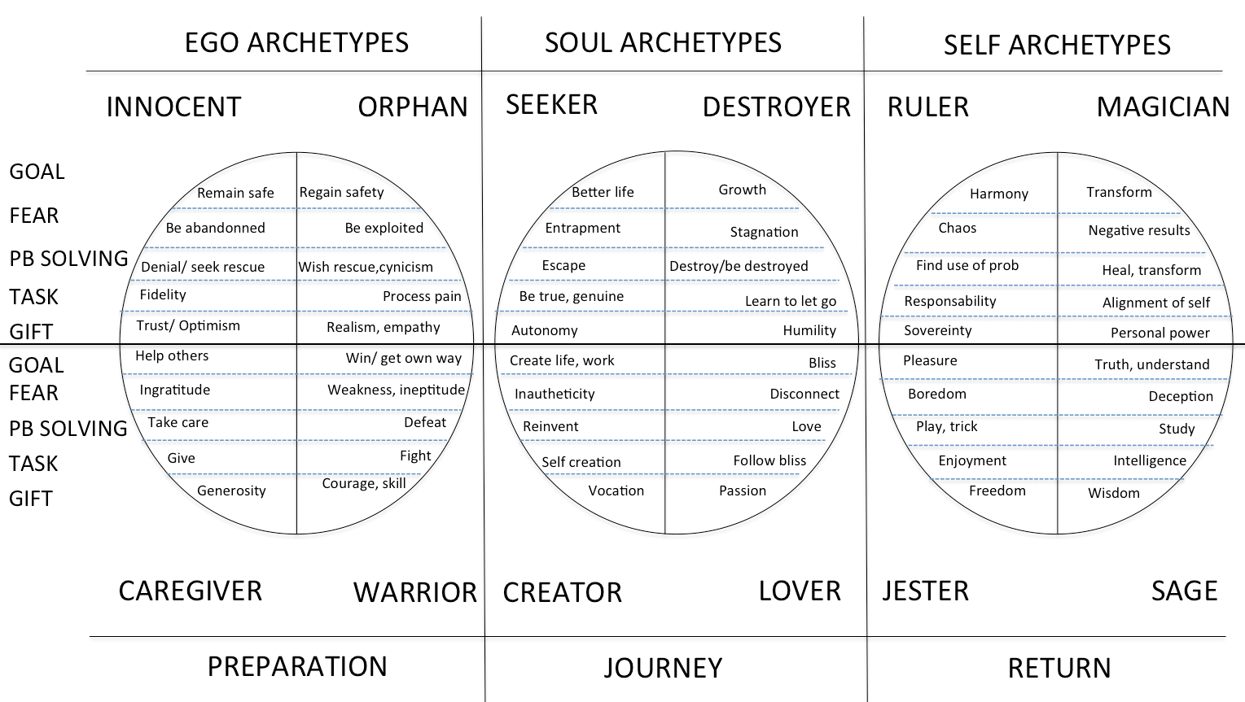

Figure 4: Archetypes and stages of individuation

Figure 5 focuses on the causes of leadership failure by showing their relationships with psychological blockings as well as rooting those blockings in the first phase of individuation which is composed of Ego archetypes. From figure 4, the following theoretical propositions can be deducted:
- Betrayal is one the main causes of leadership failure/ betrayal come from an irrational drive for safety/ Irrational drive for safety is a typical fear of the innocent archetype.
- Insensitivity is one of the main causes of leadership failure/ Insensitivity originates from a fear of being hurt/ Fear of being hurt is a typical fear of the Innocent archetype
- Selfishness is one of the main causes of leadership failure/Selfishness originates in the fear of being deprived. The fear of being deprived is a typical fear of the Orphan archetype
- Aloofness is one of the main causes of leadership failure/ Aloofness originates in the fear of being rejected/ The fear of being rejected is a typical fear of the Orphan archetype
- Arrogance is one of the main causes of leadership failure/ Arrogance originates in low self esteem/ Low self esteem is a typical fear of the Warrior archetype.
- Perfectionism is one of the main causes of leadership failure/ Perfectionism originates from the fear of failure/ The fear of failure is a typical fear of the Caregiver archetype.
The theoretical framework presented in figure 5 shows that leadership failures and their psychological blockings of leaders are rooted in the Ego archetypes, which correspond to the first phase of individuation.
EGO ARCHETYPES | BLOCKINGS | CAUSE OF FAILURE
Innocent | Irrational drive for safety  Fear of being hurt | Betrayal  Insensitivity
Orphan | Fear of being deprived  Fear of being rejected | Selfishness  Aloofness
Warrior | Low self-esteem | Arrogance
Caregiver | Fear of failure | Perfectionism

Figure 5. Relationship between category of archetypes, blockings and causes of leadership failure

4. Discussion

The objective of this research is to develop a theoretical framework for facilitating leader empowerment. Figure 3 relates the six main causes for leadership failures to six psychological blockings corresponding to these causes, and relates these blockings to three categories of archetypes, which leaders can overcome going through three stages of the individuation process proposed by Jung. As leadership failures have psychological origins, these blockings need to be addressed from a psychological perspective. Jungian theory addresses psychological blockings by acknowledging the importance of unconscious contents. If the work of Kets de Vries is closely linked and has influenced the research presented in this paper, his clinical Freudian approach, his performative orientations and his anthropomorphization of organization (by applying the mechanisms of the human unconscious to organizations) will nonetheless be important differences with the present research.
The proposed theoretical framework establishes empowered leadership as the result of a dialogue between the conscious and the unconscious. Leadership does not result only from managers’ goodwill and their intellectual grasp of leadership concepts. To become successful leaders, executives must remove psychological blockings residing in the unconscious as well as in the conscious part of their psyche. Individuation leads to a level of psychological development that enables managers to use more effectively the knowledge developed by instrumental leadership theory.
The suggested approach to leader empowerment does not invalidate currently dominating leadership theory. Providing the psychological requirement for effective leader development, the suggested approach builds the necessary basis for leadership theory to be effectively implemented. Managers can profit fully from current leadership theory only once they have overcome basic psychological blockings that prevent the managers from being empowered leaders. Leaders need to develop a strong Ego in the first phase of individuation. It is in this phase that individuals experiment behaviors and grow the qualities required to reach their objectives. However, this first ego phase is insufficient to empower leaders. To become empowered, leaders must go beyond this first stage and interact with archetypes of the second and third stages. In the second stage leaders work on their soul archetypes, engage in personal uncertainty and risk-taking. In the third stage leaders ultimately broaden their self and become their own authority by clarifying their self-archetypes. The new theoretical perspective encourages leaders to reflect upon their personal growth from a holistic psychological perspective. Becoming their own authority is what truly enables managers to become empowered leaders.
From a managerial point of view, the suggested individuation process favors a more qualitative approach to leadership both from an inner and an outer perspective. From an inner perspective, individuation enhances self-knowledge and integrity helping managers to develop a leadership style that is congruent with their specific personality. In case leaders force themselves into a leadership style suggested by a theoretical leadership model or by imitating another leader. In such cases, cognitive dissonance might manifest. Leaders tend to lack impact, charisma and credibility, and appear to be borrowing their leadership style from someone else. Individuals who are committed to a self-actualization process will naturally grow more genuine leadership abilities - a leadership style that corresponds to their true self. Such leaders develop natural authority. This authority is neither borrowed nor the expression of fears, but rather the genuine and congruent expression of a mindful vision. For having reflected upon their own leader development process, leaders are better able to contribute to the development of their followers. The legitimacy of leaders is reinforced. From the suggested perspective, holistic leader development is primarily sought out as an end in itself. It is only as an aftermath that this development becomes a means for corporate success.

Empirical research based on the suggested theoretical framework has to re-establish the proposed link between psychological blockings and leadership behavior and to test the suggested relationship between psychological blockings and ego archetypes. Research must empirically reveal the role of the integration of soul archetypes in overcoming psychological blockings and the role of self-archetypes in empowering leaders. To do so, a case study describing the evolution of a fictitious leader has been presented to corporate leaders. The story consists of three separated phases of leadership development corresponding to the three phases of individuation: (1) adaptation to the demand of the environment (ego archetypes), (2) integration of unconscious content (soul archetypes) and (3) realization of self (self-archetypes). After having read the description of the leader’s career development, self-perception and conduct in each of these phases, respondents are asked to select images and behavior that respondents perceive characterizing what the leader is going through in each particular stage. All images and behavior listed in the questionnaire for choice stem from in-depth archetypal research (Archives for Research in Archetypal Symbolism, aras.org) in order to fit the three archetypal categories: ego, soul and self-archetypes. By using projective techniques and archetypal images, this research approach accesses the respondent’s conscious and unconscious representations of leader development.

5. Conclusion

The way leadership theory has developed in the 19th and throughout the 20th century is the result of a specific paradigmatic evolution. Up until the Middle Ages, Man was merely a pilgrim of God. Things started to change at the Renaissance when Man became the center of the universe and substantially during the Enlightenment when Reason became the essence of Man. It is this paradigm shift that made technology and science become central to European culture in the 19th century and central to social progress. Management science emerged from this paradigm of technical supremacy. In line with the paradigm until recently, the literature on the subject sees leadership as primarily instrumental. Leadership theory developed under the assumption that the leader is a tool equipped with goodwill and intellectual understanding to avoid mistakes. The research presented here shows how leadership failures come primarily from psychological blockings, which need appropriate treatment to be removed. Jungian theory provides a theoretical framework and a process for such a treatment. Engaging in an individuation process enables executives to overcome ego archetypes as sources of psychological blockings. The interaction with and integration of soul and self-archetypes into conscious contents contributes to the leader´s self-actualization. Leaders become empowered by the exploration of their inner Self and a holistic psychological development. Such a development will enable leaders to apprehend reality more broadly by acknowledging, appropriately using and differentiating the material, intellectual, emotional and spiritual components of reality. Having freed leaders from their psychological blockings, such empowerment provides the psychological basis for effective use of leadership theory. Jung describes this empowerment: “…what does lie within our reach, however, is the change in individuals who have, or create for themselves, an opportunity to influence others of like mind. I do not mean by persuading or preaching- I am thinking, rather, of the well-known fact that anyone who has insight into his own actions, and has thus found access to the unconscious, involuntarily exercises an influence on his environment” (Jung, Collected Works, 2015). Through individuation an authentic, natural form of authority arises as a result of the insight leaders now possess into their actions and the contact established with the unconscious. Leadership becomes effective because it results from the connection of the individual with the Self.

References:
Adair, J. 2003. Effective Strategic Leadership. London: Pan Books.
Adair, J. 2005. The Inspirational Leader: How to Motivate, Encourage and Achieve Success. London: Kogan Page.
Alimo-Metcalfe, B. and Alban-Metcalfe, J. 2005. “Leadership: Time for a new
direction?” Leadership, Vol. 1, No. 1, p. 51-71.
Altrocchi, J. (1999). ‘Individual differences in pluralism in self-structure’. In J. Rowan & M. Cooper (Eds.), ‘The plural self: Multiplicity in everyday life’ (pp. 168-182). London, England: SAGE
Anderson, J.S (2014), “Selfish, Excessive, Greedy: The psychological causes and consequences of perception of greed”, The University of Arizona.
Antonacopoulou, E.P. and Bento, R.F. (2003). ‘Methods of Learning Leadership:
Taught and Experiential’, in Current Issues in Leadership and Management
Development, J. Storey, ed., Oxford: Blackwell Publishers, p. 81-102.
Aziz, R. (2007). The syndetic paradigm: The untrodden path beyond Freud and Jung. New York: State University of New York Press.
Avolio B.J, Walumbwa, F.O,, Weber T.J (2009) ‘Leadership: Current Theories, Research, and Future Directions’, Annual Review of Psychology Vol. 60: 421-449 (Volume publication date January
Bass, Bernard. M. ‘From Transactional To Transformational Leadership’: Learning To Share The Vision. Organizational Dynamics’, 18(3), 19-31, 1990.
Bennis, W; Thomas, R.J (2002). ‘The Crucibles of Leadership’. Harvard Business Review.
Blake, R.; Mouton, J. (1985). The Managerial Grid III: The Key to Leadership Excellence. Houston: Gulf Publishing Co
Blanchard, K. (2007). Leading at a Higher Level: Blanchard on how to be a High
Performing Leader. Harlow: Pearson Education Limited.
Blanchard, K., P. Zigarmi and D. Zigarmi. (2004). Leadership and the One Minute
Manager. London: HarperCollins Publishers.
Brown, A. (2000). The 6 Dimensions of Leadership. London: Random House.
Cartwright, R. (2002). Mastering Team Leadership. Basingstoke: Palgrave.
Boyatzis, Richard and Annie McKee. (2005) Resonant Leadership. Boston, Massachussetts: Harvard Business School Press,.
Bowles, M.L (1989). Myth, mean
Burke R. J (2006) "Why leaders fail: exploring the darkside", International Journal of Manpower, Vol. 27 Iss: 1, pp.91 – 100
Carlyle, T. (1888). On heroes, hero worship and the heroic in history Fredrick A. Stokes & Brother, New York,
Clements, C. Washbush, J.B (1999) "The two faces of leadership: considering the dark side of leader‐follower dynamics", Journal of Workplace Learning, Vol. 11 Iss: 5, pp.170 - 176
Daft, R (1983). Symbols in organizations : a dual content framework for analysis. In Organizational Symbolism, L. Pondy, P. Frost, G. Morgan and T. Dandridge, eds Greenwhich : JAI Press, pp 199-206
Daft, R. L. (2011). The Leadership experience. Fifth edition (paperback). South-Western College Publishers.
Devlin, G., H. Carty and N. Turner. (2008). Meeting the Challenge: Leadership
Development in the Cultural and Creative Industries. Cultural Leadership
Programme. Available from:
http://www.culturalleadership.org.uk/uploads/tx_rtgfiles/MeetingTheChallenge.pdf
Druckman, D and Bjork (1991). In the Mind’s Eye : Enhancing Human Performance. Washington, D.C : National Academy Press.
Fiedler, Fred E. A. (1967). Theory of Leadership Effectiveness. New York, NY: McGraw-Hill,
Fry, L.W (2003). Toward a Theory of Spiritual Leadership, The Leadership Quarterly 14 (2003) 693
Goffman Erving (1963): Behavior in Public Places: Notes on the Social Organization of Gatherings. The Free Press
Goleman, D. (2003).The New Leaders: transforming the art of leadership in to the
science of results. London: Time Warner Paperbacks.
Goleman D. (2011): Leadership: The Power of Emotional Intelligence – Selected Writings, More Than Sound
Hales, R.E.; Yudofsky, F.C, Weiss Roberts, L, (editors) The American Psychiatric Textbook of Psychiatry (6th edition).
Hogan, R; Raskin, R; Fazzini, D ; Clark, K. E.; Clark, M B. (1990). The dark side of charisma. Measures of leadership , (pp. 343-354). West Orange, NJ, US: Leadership Library of America, xvii, 636 pp.
Hollwitz, J (1991). Survey of Archetypal Dominants. Unpublished manuscipt, Creighton University, Department of Communication Studies
House, R.J. and Mitchell, T.R. (1974). Path-goal theory of leadership. Contemporary Business, 3, Fall, 81-98
Howe, M.J.A, (1982). Biographical evidence and the development of outstanding individuals. American Psychologist 37 :1071-1081
Jacobi, J. (1965). The way of individuation. New York: Harcourt, Brace & World Inc.
Jaffe, L.W. (1990). Liberating the Heart : Spirituality and Jungian Psychology. Toronto : Inner City Books
Jung, C.G (2015). The Collected Works. Princeton University Press.
Kamin, L.J. (1969). Predictability, surprise, attention and conditioning. In B.A. Campbell & R.M. Church (eds.), Punishment and aversive behavior, 279–96, New York: Appleton-Century-Crofts
Kellerman, B (2014). Bad Leadership. Havard Business School Press.
Kerenyi, K, (1975). Zeus and Hera : archetypal image of Father, Husband, Wife. Princeton University Press
Kets de Vries, M; Miller, D (1987) Interpreting organizations texts, Journal of Management Studies, vol. 24, n°3, 233-247
Kets de Vries, M; Vrignaud, P; Korotov, K; Engellau, E, Florent-Treacy, E (2006) The Development of the personality Audit: A Psychodynamic Multipe Feedback Assessment Instrument, International Journal of Human Resource Management, vol.17 n°5, 898-917
Kirkpatrick, S. A., and Locke, E.A. (1991). "Leadership: Do Traits Matter?" Academy of Management Executive 5 48–60
Levine, K.J. (2008). “Trait Theory,” in Leadership: The Key Concepts, A. Marturano
and J. Gosling, eds., Abingdon: Routledge, p.163-166.
Locke ,E.A. 1991. The Essence of Leadership. New York: Lexington Books.
Mann, M. (2012), The History of Social Power. Cambrige University Press.
Maturano, A, Gosling, J. (2008). Leadership : the key concepts, 1st Edition. London : Routledge.
Moore J.W, Schmajuk N.A (2008), Scholarpedia, 3(5):3542
McCall, M.W ; Hollenbeck, G.P. (2001). ‘ Developing Global Executives : the Lessons of International Experience ‘, Harvard Business Review Press.
McCauley, C.D (2008). Leader Development : a Review of Research. Center for Creative Leadership
McDowell, A.R (2012). Balancing act: coping strategies. White Flowers Press .
Myers, I. (1962). Manual : The Myers-Briggs Type Indicator. Palo Alto, California : Consulting Psychologists Press
Neumann, E. (1969). Depth psychology and a new ethic. Translated by Eugene Rolfe. New York: G.P. Putnam’s Sons.
Northouse, P.G. (2007). Leadership: Theory and Practice. 4th ed. Thousand
Pearson, C.S. (1991). Awakening the heroes within. Harper Collins Publishers
Progoff, I. (1969). Depth Psychology and Modern Man. Julian Press.
Rimm, S; Davis, G (2006). Education of the Gifted and the Talented. Allyn and Bacon.
Seltzer, L.F (2011). Paradoxical Strategies in Psychotherapy. Wiley Series on Personality Processes.
Sloane, P. (2007). The Innovative Leader. London: Kogan Page.
Spencer, H. (1896). The Study of Sociology. Appleton.
Stein, M. and Hollwitz, J. (1992). Psyche at Work : Workplace Applications of Jungian Analytical Psychology. Chiron Publications.
Stogdill, R. M. (1948). "Personal Factors Associated with Leadership: A Survey of the Literature." Journal of Psychology 25 335–71
Storr, A (1983). The Essential Jung ; selected writings. Princeton University Press
Townley, B. (2008). Reason’s Neglect: Rationality and Organizing. Oxford Scholarship Online.
Vroom, V. H., and Yetton, P. (1973). Leadership and Decision Making. Pittsburgh, PA: University of Pittsburgh Press
Winch, G. (2014) Emotional First Aid: Healing rejection, Guilt and Failure. Hudson Street Press.
Yukl, G. (1994). Leadership in Organizations. Englewood Cliffs, NJ: Prentice-Hall

